# WORKSHEET-1 SQL

--------------------------------Multi Correct Answer--------------------------------------

1. AD
2. ABC

------------------------------One Correct Answer----------------------------

1. B
2. B
3. A
4. C
5. B
6. B
7. B
8. C

---------------------------------Subjective Answers--------------------------------

1. What is data-warehouse?

Ans- A data warehouse is a technique of gathering and collecting data from various heterogeneous source in order to analyse the real time business data which is further transformed into information.

1. What is the difference between OLTP VS OLAP?

Ans - OLTP stands for **Online transaction processing** and OLAP stands for **Online Analytical Processing.**

* Online Analytical Processing (OLAP) is a category of software tools that analyse data stored in a database whereas Online transaction processing (OLTP) supports transaction-oriented applications in a 3-tier architecture.
* OLAP creates a single platform for all type of business analysis needs which includes planning, budgeting, forecasting, and analysis while OLTP is useful to administer day to day transactions of an organization.
* OLAP is characterized by a large volume of data while OLTP is characterized by large numbers of short online transactions.
* In OLAP, data warehouse is created uniquely so that it can integrate different data sources for building a consolidated database whereas OLTP uses traditional DBMS.

1. What are the various characteristics of data-warehouse?

Ans-Below are the characteristics of the data warehouse: -

* 1. **Subject- Oriented**- It means that the data warehouse is supposed to handle specific

theme which is more defined. Data warehousing is always subject oriented as it deals with the information about a theme instead of organisation current task.

* 1. **Integrated**- It is somewhere same as subject orientation which is made in a reliable format. Integration means founding a shared entity to scale the all similar data from the different databases**.**
  2. **Time-Variant –**In this data is maintained via different intervals of time such as weekly, monthly, or annually etc. It founds various time limit which are structured between the large datasets and are held in online transaction process (OLTP).
  3. **Non-Volatile –**As the name defines the data resided in data warehouse is permanent. It also means that data is not erased or deleted when new data is inserted. It includes the mammoth quantity of data that is inserted into modification between the selected quantity on logical business.

1. What isstar schema?

Ans - **Star schema** is the fundamental schema among the data mart schema and it is simplest. This schema is widely used to develop or build a data warehouse and dimensional data marts. It includes one or more fact tables indexing any number of dimensional tables. It is also efficient for handling basic queries

It is said to be star as its physical model resembles to the star shape having a fact table at its centre and the dimension tables at its peripheral representing the star’s points. Below is an figure to demonstrate the Star Schema

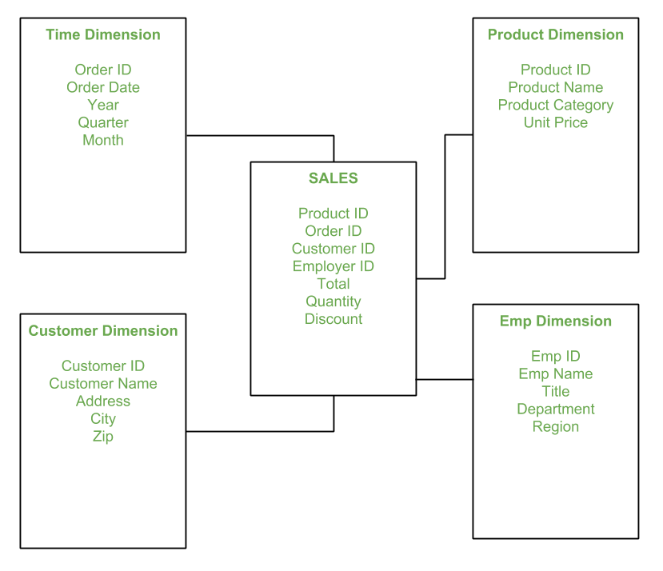

1. What do you mean by SETL?

Ans- SETL is a [high-level programming language](https://www.webopedia.com/TERM/H/high_level_language.html) which stands for set theory for language.

In SETL every statement is terminated by a semicolon. It is based on set theory and used for mathematical  calculation .[Variable](https://www.webopedia.com/TERM/V/variable.html) names are case-insensitive and are automatically determined by their last assignment. Primitive operations in SETL include set membership, union, intersection, and power set construction